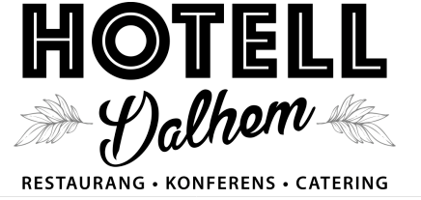
Sausage deluxe!
Here you will find hot dog stand in luxury taping.
We do everything from scratch, sausages, bread and all the accessories. We try to make use of Gotland and organic raw materials as much as possible. The meat is as far as possible from Gotland and of the highest quality.
We have no special menu for the children, however, we make smaller portions of all food, such as 90 g of burgers, and it costs half the price.
If you want to eat in our restaurant, we need to know it by 14.00 the same day. Simply make the reservation by sms to Pia 004670-77 29 112 it is also possible to call.
Menu
Hamburgers with bread, served with cheese, smoked BBQ sauce, dressing, french fries and a dip sauce to the french fries SEK 155
Vegoburger, a burger made of carrot, buckwheat and a lot of good spices, is served with smoky BBQ sauce, dressing, strips and a dip sauce for the strips SEK 140
Halloumiburger, homemade Halloumicheese, served with smoked BBQ sauce, dressing, french fries and a dip sauce to the french fries SEK 155
Mashed potatoes with sausage, served with shrimp salad and pickled red onion SEK 130
French fries with sausage, served with cucumber mayonnaise and pickled red onion SEK 130
Wrap, thin bread with mashed potatoes, sausage and prawn salad SEK 145
Fish n 'chips, fried cod served with french fries and tartar sauce SEK 130

